
AI-Based Language Learning Companion


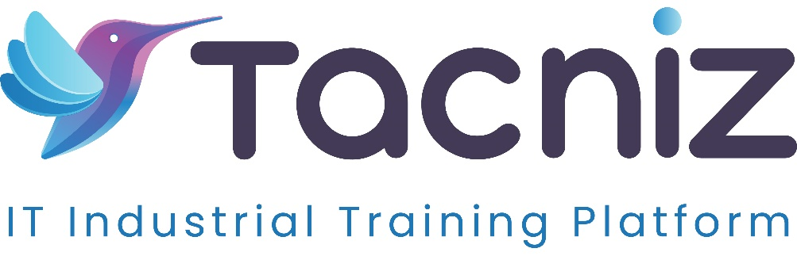

Problem Statement
Learning a new language can be challenging, especially when it comes to practicing speaking skills and receiving real-time feedback. Traditional methods like textbooks or apps often lack interactive, conversational practice, and personalized feedback. An AI-powered language learning assistant can engage users in real-time conversations, offer corrections, introduce new vocabulary, and simulate real-world dialogues, enhancing the learning experience.

Type
  - AI-based Language Learning and Conversational Practice Tool.

Industry Area
  - Education, E-Learning, Language Training, Mobile Applications.

Software Expertise Required
  - Natural Language Processing (NLP): Use Python (spaCy, NLTK, or GPT models) to build conversation models that understand and respond in real-time.
  - Speech Recognition & Synthesis: Integrate tools like Google Speech-to-Text or Amazon Polly to allow users to practice speaking and receive verbal feedback.
  - Machine Learning: Use deep learning models (TensorFlow, PyTorch) to improve the assistant’s ability to correct grammar, suggest vocabulary, and adapt to the user's skill level.
  - Mobile App Development: Flutter or React Native for cross-platform app development (iOS and Android).
  - Backend Development: Python (Flask/Django) or Node.js to handle real-time conversations, feedback, and user progress tracking.
  - Database: MySQL, PostgreSQL, or MongoDB for storing user profiles, vocabulary, conversation history, and learning progress.

Use Cases
  - Real-Time Conversations: Users can converse with the AI assistant in their target language, simulating real-world situations like ordering food, asking for directions, or having casual conversations.
  - Vocabulary Building: The system introduces new words and phrases relevant to the user's conversation context and skill level, helping expand their vocabulary.
  - Pronunciation Practice: The AI assistant provides real-time feedback on pronunciation, helping users improve their speaking skills.
  - Grammar Corrections: The system highlights grammar mistakes during conversations and offers corrections and explanations.
  - Progress Tracking: The app tracks user performance over time, adjusting the difficulty of conversations and offering personalized feedback.

Outcomes
  - Enhanced language learning experience through real-time, interactive conversations that simulate real-world scenarios.
  - Continuous improvement in speaking, grammar, and vocabulary skills through real-time feedback and adaptive learning.
  - Personalized learning experience that adjusts to the user’s progress and skill level, keeping learners engaged.

Benefits
  - For Language Learners:
    - Provides immersive, real-time language practice without the need for a human tutor.
    - Improves speaking skills, vocabulary, and grammar through immediate feedback and corrections.
    - Simulates real-world conversations, helping learners gain confidence in everyday communication.
  - For Educators:
    - Offers an interactive tool for students to practice language outside of the classroom.
    - Provides insights into each student’s progress and learning challenges, helping educators tailor their lessons.
  - For E-Learning Platforms:
    - Enhances user engagement by providing an interactive and adaptive language learning companion.
    - Increases retention by offering personalized learning experiences and real-world conversational practice.

Duration
  - Estimated 5-6 months.

